| **Test Name** | Manually start pump when pump is not running [No Timer] |
| --- | --- |
| **Use Case Tested:** | Manually turn the pump on |
| **Test Description:** | This test verifies that the pump can be turned on using the manual on/off switch. |
| **Pre-conditions** | * Pump Not Running; * System State of Pump: Not running; * ThingsBoard has not asked the pump to start running via manual operation. * Automation: Off. * Est. Timer: Off. * Custom Timer: Off. |
| **Post-conditions** | * Running LED: On * Manual Switch: On * Transmit Status: Successful |
| **Notes:** |  |

|  | **TEST STEP** | **EXPECTED TEST RESULTS** |
| --- | --- | --- |
|  | Use the Dash to send a manual pump on message. | * Switch changes from off to on. * Transmit status becomes “In-Transit”. * Event Log shows Manual On message. * Simulator receives the message. |
|  | Send Status from simulator | * Sim sends status message with pump still off. * Dash still displays “In-Transit. * Simulator changes it’s running flag to checked. |
|  | Send Status from simulator | * Sim sends status message with pump running flag. * Dash displays Running LED as “On”. * Transmit status displays “Successful”. |

|  |  |  |  |  |  |
| --- | --- | --- | --- | --- | --- |
| **Test Data Table** | | | | | |
|  | **1** | **2** | **3** | **4** | **5** |
| [Data field 1] | [data set 1 input value for field 1] |  |  |  |  |
| [Data field 2] | [data set 1 input value for field 2] |  |  |  |  |
| [Data field 3] | [data set 1 input value for field 3] |  |  |  |  |

**Results**

05/09/2020

**SUCCESS!**

Manual On sent. Received. Updated.

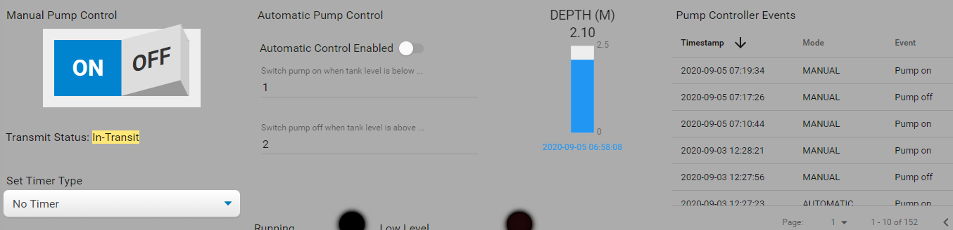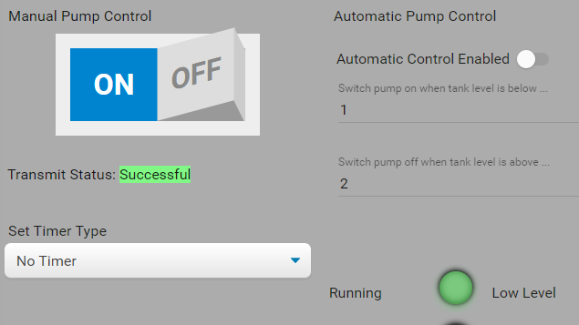

9/9/2020 – On site test at OAI.

Success.

NOTE: The downlink was missed on the first status message in step 2 and a second status message was required. I am not treating this as a fail because LoRaWAN does not guarantee message delivery.

Step 1.

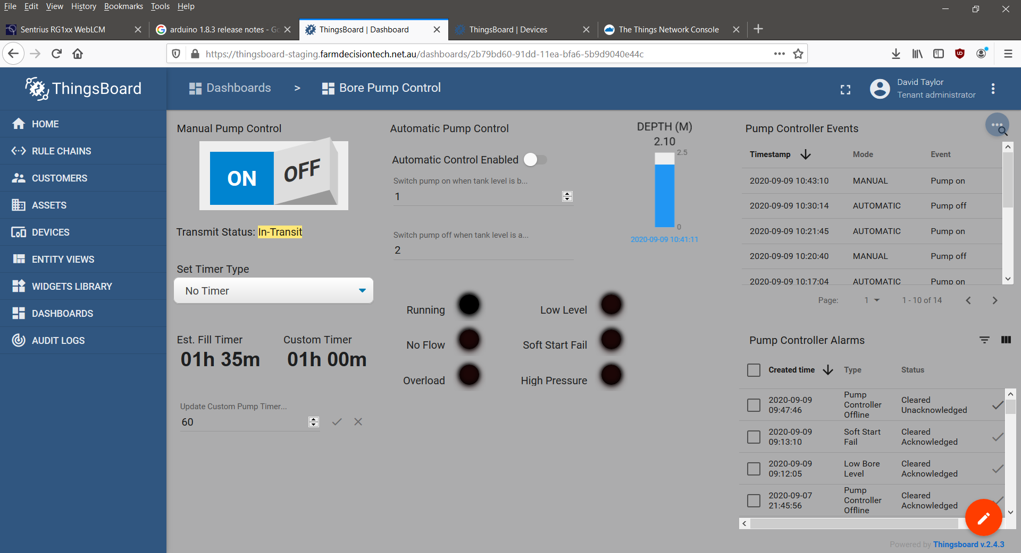

Step 2.

10:44:21.035 -> Send operator requested status message.

10:44:21.035 -> LoRaWAN will encode and send this message: {'pumpRunning':0,'boreLowLevel':0,'softStartFail':0,'pumpOverload':0,'controllerRestart':0,'highPressure':0,'noFlow':0}

10:44:21.035 -> Sending status byte: 00

10:44:23.169 -> EV_TXCOMPLETE (includes waiting for RX windows)

10:45:23.005 -> Send operator requested status message.

10:45:23.005 -> LoRaWAN will encode and send this message: {'pumpRunning':0,'boreLowLevel':0,'softStartFail':0,'pumpOverload':0,'controllerRestart':0,'highPressure':0,'noFlow':0}

10:45:23.005 -> Sending status byte: 00

10:45:24.130 -> EV_TXCOMPLETE (includes waiting for RX windows)

10:45:24.130 -> Received reply with 1 bytes:

10:45:24.130 -> 01

10:45:24.130 -> callback got data 1

10:45:24.130 -> Switched pump on.

10:45:24.130 -> Sending status due to state change.

10:45:24.130 -> LoRaWAN will encode and send this message: {'pumpRunning':1,'boreLowLevel':0,'softStartFail':0,'pumpOverload':0,'controllerRestart':0,'highPressure':0,'noFlow':0}

10:45:24.130 -> Sending status byte: 01

10:45:29.779 -> EV_TXCOMPLETE (includes waiting for RX windows)

Step 3.

